Lecture no 1: Core web concepts

These notes cover the fundamental concepts of the web, from its underlying architecture to the core protocol for communication.

The Client-Server Model

In this model:
- The Client is an application or device (like your phone or a web browser) that needs a resource or service. It always starts the conversation by making a request.
- The Server is a powerful computer that has the resource or service (like a webpage, data, or an email file). It patiently waits for requests.
- The client sends a request (e.g., "Give me the Google homepage").
- The server processes the request and sends a response back to the client (e.g., "Here is the HTML code for the Google homepage").
Goal: To separate the task of requesting (client) from the task of providing (server), which makes the whole system more organized, efficient, and easier to scale.
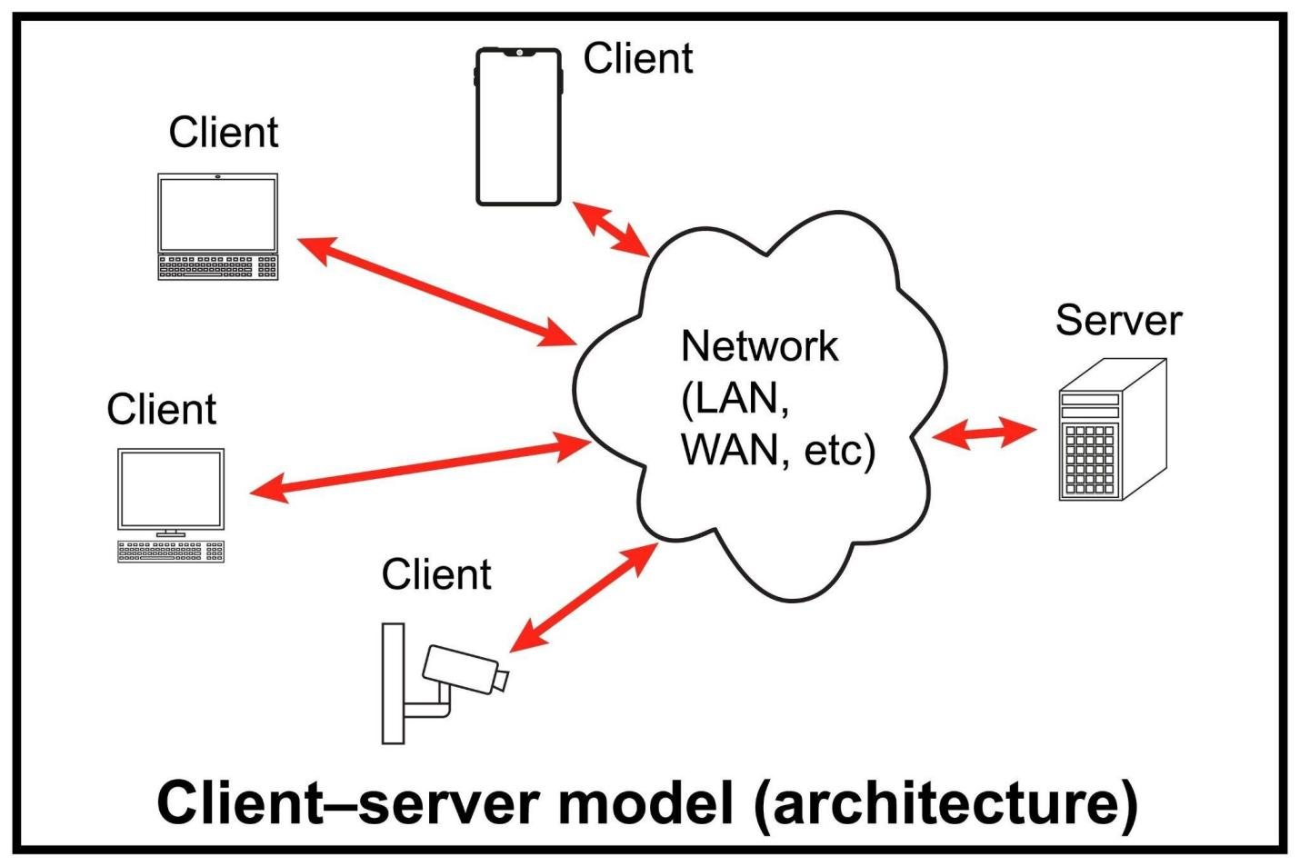

Key Advantages:
- Centralization: Resources and security are controlled centrally on the server.
- Scalability: Servers can be upgraded independently to handle more clients.
- Efficiency: Clients don't need powerful resources to store all the data; they just request it.

Web Browsers

A Web Browser is a software application that allows users to access and view websites. It acts as the client in the client-server model for the web.
- Primary Functions:
  - Requesting: Uses protocols like HTTP to request web pages and resources from a server.
  - Rendering: Interprets and displays the HTML (structure), CSS (style), and JavaScript (interactivity) content sent back from the server, turning code into a visual webpage.
  - Navigation: Manages history, bookmarks, and allows users to follow hyperlinks.
- Key Components:
  - User Interface: The visible parts (address bar, back/forward buttons).
  - Browser Engine: Coordinates the actions between the UI and the rendering engine.
  - Rendering Engine (Layout Engine): Renders the requested content

TCP/IP (Transmission Control Protocol/Internet Protocol)

TCP/IP is the foundational suite of communication protocols that defines how data is exchanged over the internet.
Protocol | Function | Role
IP (Internet Protocol) | Addressing and Routing | Responsible for addressing and routing packets of data so they arrive at the correct destination. Each device on a network has a unique IP address (e.g., 192.168.1.1).
TCP (Transmission Control Protocol) | Reliable Data Transfer | Ensures the reliable delivery of data packets. It breaks data into smaller packets, reassembles them at the destination, and requests re-transmission of any lost packets ("handshake" process).
- Analogy: IP is like the postal address on an envelope, ensuring it goes to the right location. TCP is like the process of confirming all the pages of a long letter have arrived and are in the correct order.

DNS (Domain Name System)

DNS is the internet's phonebook. It translates human-readable domain names into machine-readable IP addresses.
- Domain Name: The easy-to-remember address of a website (e.g., www.example.com).
- IP Address: The numerical address the computer needs to locate the server (e.g., 93.184.216.34).
- Process (DNS Lookup): When you type a domain name into a browser, the browser queries a DNS server. The DNS server recursively searches until it finds the corresponding IP address, which it sends back to the browser. This allows the browser to initiate the connection.

URLs (Uniform Resource Locators)

A URL is the complete address used to specify the location of a resource (like a web page, image, or file) on the internet and the protocol needed to access it.
Structure:
protocol://domain:port/path/resource?query#fragment
- protocol: Specifies the access method (e.g., http, https, ftp).
- domain: The server's name (Domain Name) (e.g., www.example.com).
- port: The gate number on the server (often omitted; HTTP uses 80, HTTPS uses 443).
- path: The specific location of the resource on the server (e.g., /articles/).
- resource: The specific file name (e.g., index.html).
- ?query: Optional information passed to the server (key-value pairs, often for searches).

The Evolution of the Web

The web has evolved through several distinct phases:
Phase | Description | Key Technologies/Focus
Web 1.0 (The Read-Only Web) | 1991–2004. Static, passive content. Users were primarily consumers of information. | Static HTML pages, frames, basic hyperlinks.
Web 2.0 (The Social/Participative Web) | 2004–Present. Dynamic, interactive content. Focus on user-generated content, social networking, and collaboration. | AJAX, JavaScript frameworks, Blogs, Wikis, Social Media.
Web 3.0 (The Semantic/Decentralized Web) | Emerging. Focus on AI-driven data organization, decentralized applications (dApps), and the "Internet of Things." | Blockchain, Machine Learning, Semantic Web technologies.

Introduction to the HTTP Protocol (Hypertext Transfer Protocol)

HTTP is the core application-layer protocol for data communication on the World Wide Web. It's a stateless protocol, meaning each request-response is treated as an independent transaction, and the server does not inherently remember past interactions (though cookies are used to maintain state).

HTTP Requests

An HTTP Request is a message sent from the client (browser) to the server to perform an action.
- Components of a Request:
  - Request Line: Includes the HTTP Method (e.g., GET), the URL, and the HTTP Version (e.g., HTTP/1.1).
  - Headers: Key-value pairs providing metadata (e.g., User-Agent (client info), Accept-Language).
  - Body (Optional): Contains data to be sent to the server (e.g., form data when using POST).

HTTP Responses

An HTTP Response is the message sent back from the server to the client in reply to a request.
- Components of a Response:
  - Status Line: Includes the HTTP Version and a Status Code (e.g., HTTP/1.1 200 OK).
  - Headers: Key-value pairs providing metadata (e.g., Content-Type, Content-Length).
  - Body: Contains the requested resource data (e.g., HTML code, an image file, JSON data).

HTTP Methods
HTTP methods to define desire actions the client(web browser) want to perform on the specific resource on the server

Methods (or verbs) define the desired action to be performed on the identified resource.
Method | Role | Use Case
GET | Retrieve Data | Requests data from a specified resource. It should only retrieve data and have no other effect.
POST | Submit Data | Submits data to be processed to a specified resource. Often used for sending form data to a server.
PUT | Update/Replace | Uploads or completely replaces a current representation of the target resource with the uploaded content.
DELETE | Remove | Deletes the specified resource.
HEAD | Get Headers | Requests the headers only, without the response body. Useful for checking a resource's existence or modification time.

HTTP status codes are three-digit numbers returned by a server in response to an HTTP request made by a client (like a web browser). They indicate the outcome or status of the request.
The codes are grouped into five classes, each representing a different type of response:

Status Code Classes

Class Range | Name | Meaning | Example Codes
100−199 | Informational | The request was received and understood. The client should continue with the request or wait for a final response. | 100 (Continue)
200−299 | Success | The action was successfully received, understood, and accepted. | 200 (OK), 201 (Created), 204 (No Content)
300−399 | Redirection | Further action needs to be taken by the client to complete the request, usually involving an automatic redirection. | 301 (Moved Permanently), 302 (Found), 304 (Not Modified)
400−499 | Client Error | The request contains bad syntax or cannot be fulfilled. The client seems to be at fault. | 400 (Bad Request), 403 (Forbidden), 404 (Not Found)
500−599 | Server Error | The server failed to fulfill an apparently valid request. The server is at fault. | 500 (Internal Server Error), 503 (Service Unavailable)

Key Examples

- 200 OK: The standard response for successful HTTP requests.
- 301 Moved Permanently: The resource has been permanently moved to a new URL. Search engines will update their links.
- 404 Not Found: The server can't find the requested resource. This is perhaps the most famous error code.
- 500 Internal Server Error: A generic error message, given when an unexpected condition was encountered and no more specific message is suitable.

